An Ecosystem That Perfectly Synchronizes User Psychology and Profitability

Idle Birth

Product Vision & Business Structure

SHOGUN STUDIOS / 2026

Game Concept
Concept | Value
Title | Idle birth
Subtitle | …
Description | The player becomes the God of Evolution, guiding unknown life from an Amoeba onward.  A completely new point activity experience shaped by choices and consequences.
Genre | Point activity
Theme | Cute, chill
Setting | Friendly Laboratory where player try to be a god of evolution
Player Role | God of Evolution
Core Gameplay | Control Creature Evolution
Objective | Complete the Full Collection, collect Rakuten points
Progression | Obtain a New Creature each cycle
Unique Selling Point | Not simply a "reward-earning app," but clearly establishing the game identity  as an "evolution simulation game" where player decision-making (evolution policy / build construction) is  involved.
Art Style | Chibi, cute
Audio (BGM/SFX) | BGM: low ambient hum; SFX: loud, sharp, reactive sounds
Target Audience | Women (10 - 40)
Platform | Android, IOS

References
Figma flow: https://www.figma.com/design/rhQbQlId7SlAVQkfK1jSPx/Rice-Plant-Protect-Project-Planner?node-id=1304-793&t=TM1JDaOHr58bPY9p-1
Creature data:
https://docs.google.com/spreadsheets/d/1_H2lq6mEzw7lEmKHVbp_C4pWExQf9ifiRXW0-jebrdE/edit?gid=1329993037#gid=1329993037

Game cycle
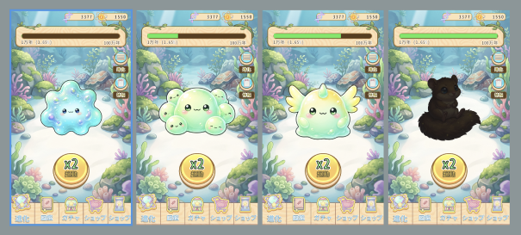

A full game cycle includes:
- Mix Ingredients
- Start as an Ancient Amoeba
- Players can go online anytime to control evolution in the Lab and play the Gacha.
- Singularity Point: At 100% of the cycle, the player can use the Final Touch.
- Result: Gain the creature and +1000 DNA +??? Potential Point (This value can be changed when balancing, the Potential Point varies among creatures)

Key Aspects of Every Cycle:
- Creature growth is tracked from 0% to 100% per cycle.
- Each cycle lasts 60 minutes.
- The evolution time is uniform, it is always 60 minutes for each cycle.
- The only way to reduce the cycle time is by using the “Speed Up” feature.
- Mixing ingredients only determines the creature that is likely to spawn.

Game reward
After each Cycle, player will be reward:
- +1000 DNA +??? Potential Point (This value can be changed when balancing, the Potential Point varies among creatures)
- A creature based on mixing ingredients and chance at that moment.
- We have: Reward formula + Final touch => Final Reward
- Please look at the Reward formula to understand how mixing ingredients affects the Reward formula.
- Please look at Control evolution by Final Touch to understand how the Final Touch affects the Reward formula.
Reward modified by ad: Popup show up and let player watch a CM to x10 their Potential Point: 100 => 1000
Reward modified by final touch: please look at Control evolution by Final Touch

Core gameplay
Gameplay includes:
- Speed up by Boost button
- Speed up by Time Skip offer
- Control evolution by mixing Ingredients.
- Control evolution by the Final Touch.
- Collection of Creatures.
- Gacha.
- Evolution Timeline.


(1) Speed up by Boost button
Boost button:
- Tapping the Boost button grants 2x speed boost in 60 seconds. When tapping the Speed Up button, the ad popup will show up for player to confirm.
- The boost button has a green cooldown indicator in its border.
- Current Speed text: It will display the current evolution speed; normally it will show x1, tapping the acceleration button will show x2.

(2) Speed up by Time Skip offer
The “Skip” popup allows the user to watch an ad and skip time ahead. It will show Automatically base on each Occurrence’s trigger period,
- It will show 30 seconds after opening the game and when Skip offers a condition satisfied.
- It will not show again in the same period if the player denied it once.
- It will not show in the new period that players skip to it. For example, if a player at the 1st period, they skip time to the 2nd period, the offer will not show in this 2nd period but will show in the 3rd period.
- The ad popup will show up when click Yes, after that the game will Reduce remaining gauge by 30%
Occurrence | SKIP TIME trigger timing | Role | Effect
1st | When evolution gauge reaches 10%, trigger period between 10-45% (base on when they open the game) | Prevent early drop-off | Reduce remaining gauge by 30%
2nd | When evolution gauge reaches 45%, trigger period between 45-70% (base on when they open the game) | Mid-cycle time skip · main revenue | Reduce remaining gauge by 30%
3rd | When evolution gauge reaches 70%, trigger period between 70-100% (base on when they open the game) | Late-cycle time skip + singularity flow | Reduce remaining gauge by 30%

Example Case of a 60-minute evolution 1st: when 10% is reached
- Normally, 6 minutes have elapsed.
- Elapsed: 6 min / Remaining: 54 min
- Watch ad → reduce remaining by 30%
- 54 min × 70% = 37.8 min. At this point, projected completion is 6 min + 37.8 min = 43.8 min
2nd: when 45% is reached
- The moment progress reaches 45% within the 37.8 min remaining after the 1st skip.
- In normal terms this is the 27-minute mark, but after the 1st skip the actual elapsed time is around 21 minutes.
- Progress 45% / Remaining: 33 min
- Watch ad → reduce remaining by 30%, 33 min × 70% = 23.1 min
3rd: when 70% is reached
- At 70% progress, the remaining time under the 60-minute baseline is 18 minutes.
- Progress 70% / Remaining: 18 min
- Watch ad → reduce remaining by 30%
- 18 min × 70% = 12.6 min
- Even after the 3rd ad, about 12-13 minutes remain, so users are unlikely to think "I can already wait it out, no ad needed."

Example: Player Online Mid-Period
If a player is online at 20% progress, remaining 80%, the skip offer will appear 30 seconds after opening the game. If the player accepts it, the time will skip to 30% of 80% = 24%. Time remaining will be 56% (80% - 24% = 56%)
To prevent farming creatures by skipping time, the offer will not appear again during this period until the player reaches the 3rd occurrence.

(3) Control evolution by mixing ingredients
Current ingredients include:
- Drop of Life
- Light of Mystery
- Mecha Fragment
- Crystal Of Wisdom
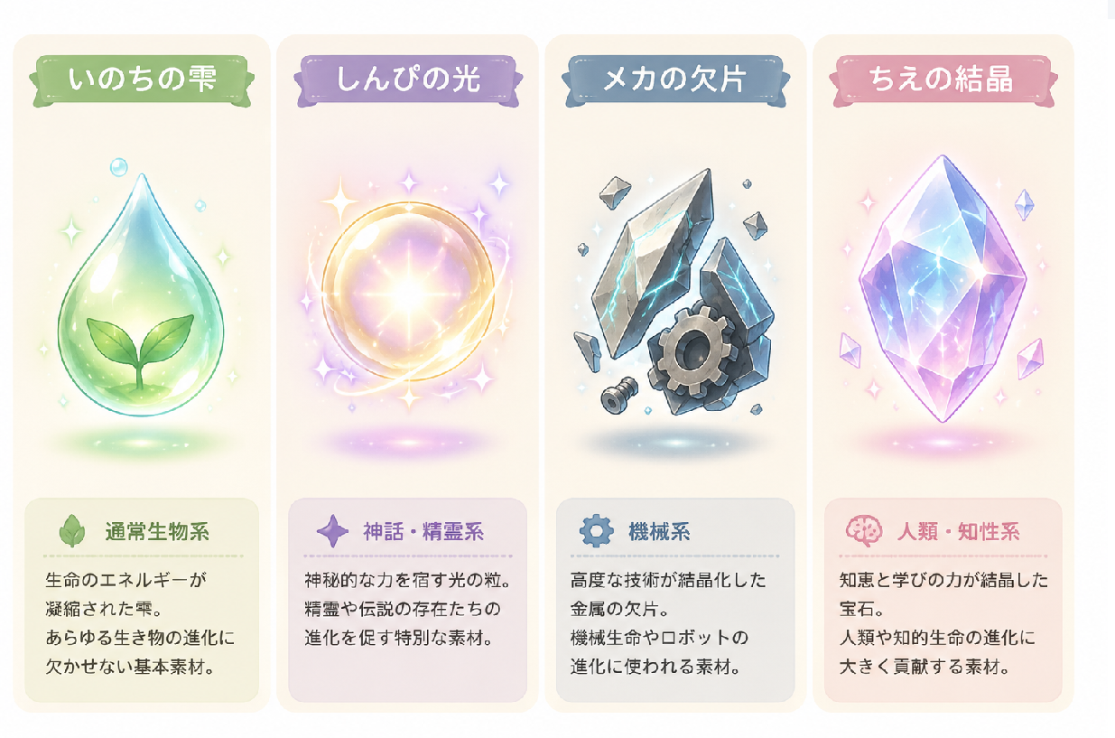

Name | Category | Description
Drop of Life (いのちの雫) | Ordinary Biological | A droplet condensed with the energy of life. An essential basic ingredient for the evolution of all living creatures.
Light of Mystery  (しんぴの光) | Mythical / Spirit | A grain of light imbued with mystical power. A special ingredient that promotes the evolution of spirits and legendary beings.
Mecha Fragment  (メカの欠片) | Mechanical | A metallic fragment crystallized from advanced technology. An ingredient used for the evolution of mechanical life and robots.
Crystal of Wisdom  (ちえの結晶) | Humanity / Intelligence | A gem crystallized from the power of wisdom and learning. An ingredient that greatly contributes to the evolution of humans and intelligent life.
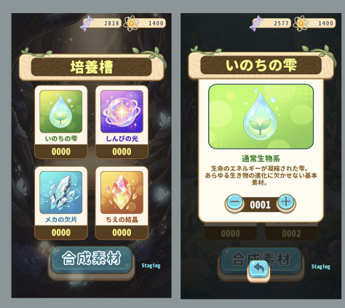
The UI is called the Growth Vat.
Adjust the amount of Ingredients to modify the evolution:
- Costs DNA.
- Only appears at the beginning of evolution.

The choice of ingredients will determine the resulting creature.
ID | Name | Potential Point | Cost
A | Drop of Life | 10 | 50 x (N^1.5)
B | Light of Mystery | 10 | 50 x (N^1.5)
C | Mecha Fragment | 10 | 50 x (N^1.5)
D | Crystal Of Wisdom | 10 | 50 x (N^1.5)
N: The current quantity of the ingredient in the Growth Vat.
Reward formula:
- Evolution Potential Point = (A + B + C + D) x Multiply Value (Example: (30 + 20 + 30 +40) x 1 = 120) (Quantity of A,B,C,D is 3,2,3,4)
- In every cases: Multiply Value = 1
- If the player uses Final Touch Evolution Boost: Multiply Value = 2 (Example: (30 + 20 + 30 +40) x 2 = 240)
- We choose the nearest creatures that have the closest mixing ingredients Potential Point. (For example mixing ingredients Potential Point is 120, we choose the closest point is 100, and we have 6 creatures that have an ID that have point 100 => ID: 2,3,4,5,6,7.
- Reward will be a random creature between ID: 2,3,4,5,6,7.

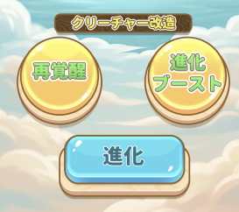
(4) Control evolution by final touch
The Final Touch system includes two features: Re-evolution and Evolution Boost.
(1): Re-evolution: Reruns the Reward formula. Cost: Ads + 100 Potential Point
(2): Evolution Boost: Reruns the Reward formula with a boosted evolution Potential Point (x2 the current evolution Potential Point). Cost: Ads + 200 Potentia Point

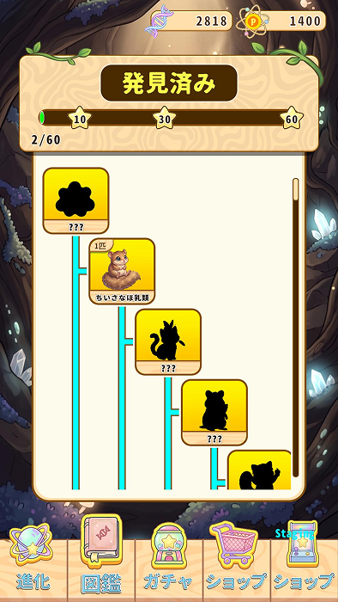

(5) Collection of creatures
The Creature Codex displays the collection of creatures already discovered.
Each creature can be collected multiple times (e.g., "03" indicates the number collected).
Reward player DNA or Potential Point when they reach 40% 80% and 100% the total creatures.

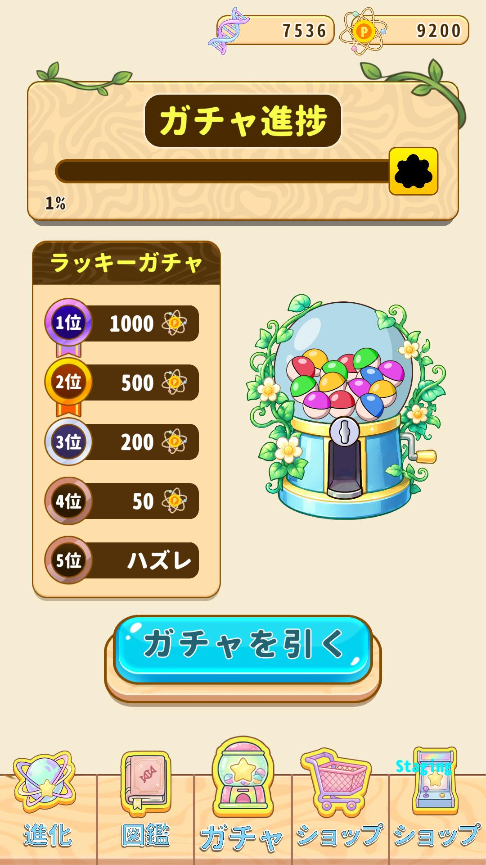
(6) Gacha
Players can play gacha for some potential reward. Costs DNA.
Gacha yield:
- 1000 Potential Point
- 500 Potential Point
- 200 Potential Point
- 50 Potential Point
- Nothing
Each gacha play add 1% gacha bar progress
At 100% progress, unlock a random creature (From 100 - 300 Potential Point) (may get the creature that player already has). Reward: Random creature + Its Potential Point

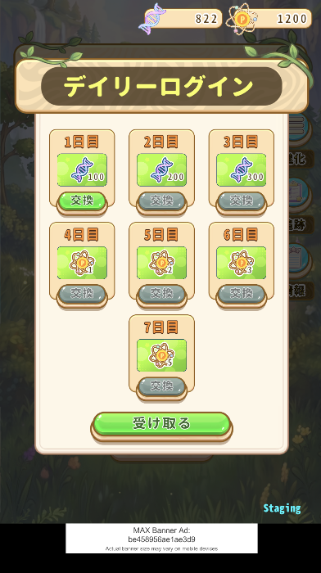
Daily Rewards

The following table details the login rewards designed to encourage consistent player engagement. The rewards scale in value throughout the week, culminating in the distribution of high-value Potential Points.

Day | Reward Type | Amount
Day 1 | DNA | 100
Day 2 | DNA | 200
Day 3 | DNA | 300
Day 4 | Potential Point | 1
Day 5 | Potential Point | 2
Day 6 | Potential Point | 3
Day 7 | Potential Point | 5

Buttons:
- Button in each reward slot: It will enable when the claimable day reaches. When clicked, the confirm popup will show up, and the player will have the option to choose if they want to double the reward (watch ads) or only claim it normally.
- Button at bottom: when clicked, it will find the all claimable days and click on them and claim all the rewards.
Mechanisms:
- Day progress: one step per JST day logged in, consecutive-login streak.
- When missing a day: back to Day 1, unclaimed rewards are forfeited.
- Catch-up: unlocked but unclaimed days can be claimed together later.
- When the cycle resets: only after all 7 days have been claimed.
- The double the reward (watch ads) only have effect on each individual claim.

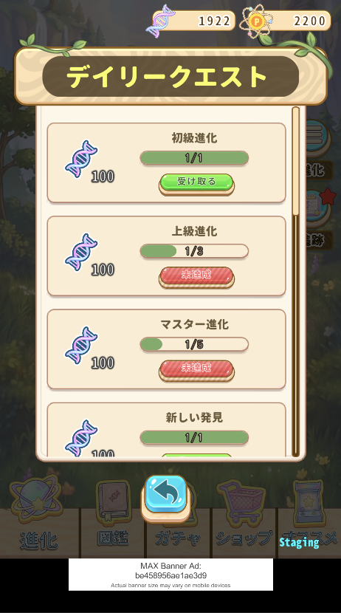
Daily Missions
Daily missions serve three strategic roles beyond merely granting rewards:

Boosting User Retention:

They stabilize DAU (Daily Active Users) by motivating players to launch the game and complete specific tasks every day.
Facilitating the Game Cycle:

They streamline overall game progression by encouraging users to engage in key actions, such as "evolving" characters or "mixing materials."
Optimizing Monetization:

They maximize ad revenue without compromising the user experience by incorporating ad viewing into the missions.

ID | Mission name | Reward | Required
1 | Novice Evolution | 100 DNA | Evolve 1 creature
2 | Advanced Evolution | 100 DNA | Evolve 3 creatures
3 | Master Evolution | 100 DNA | Evolve 5 creatures
4 | New Discovery | 100 PP | Unlock 1 new creature
5 | Rising Star | 100 PP | Unlock 2 new creatures
6 | Evolutionary Breakthrough | 100 PP | Unlock 3 new creatures
7 | Quick Mix | 100 DNA | Mix 10 ingredients
8 | Batch Blend | 100 DNA | Mix 50 ingredients
9 | Master Chef | 100 DNA | Mix 200 ingredients
10 | Ad Support | 1000 DNA | Watch 1 ad
11 | Re-evolution Trigger | 100 DNA | Use re-evolution
12 | Evolution Speedup | 100 DNA | Use boost evolution

Creature information
Please check Creature data
Each creature has 2 type of information to show: predictive information and final information

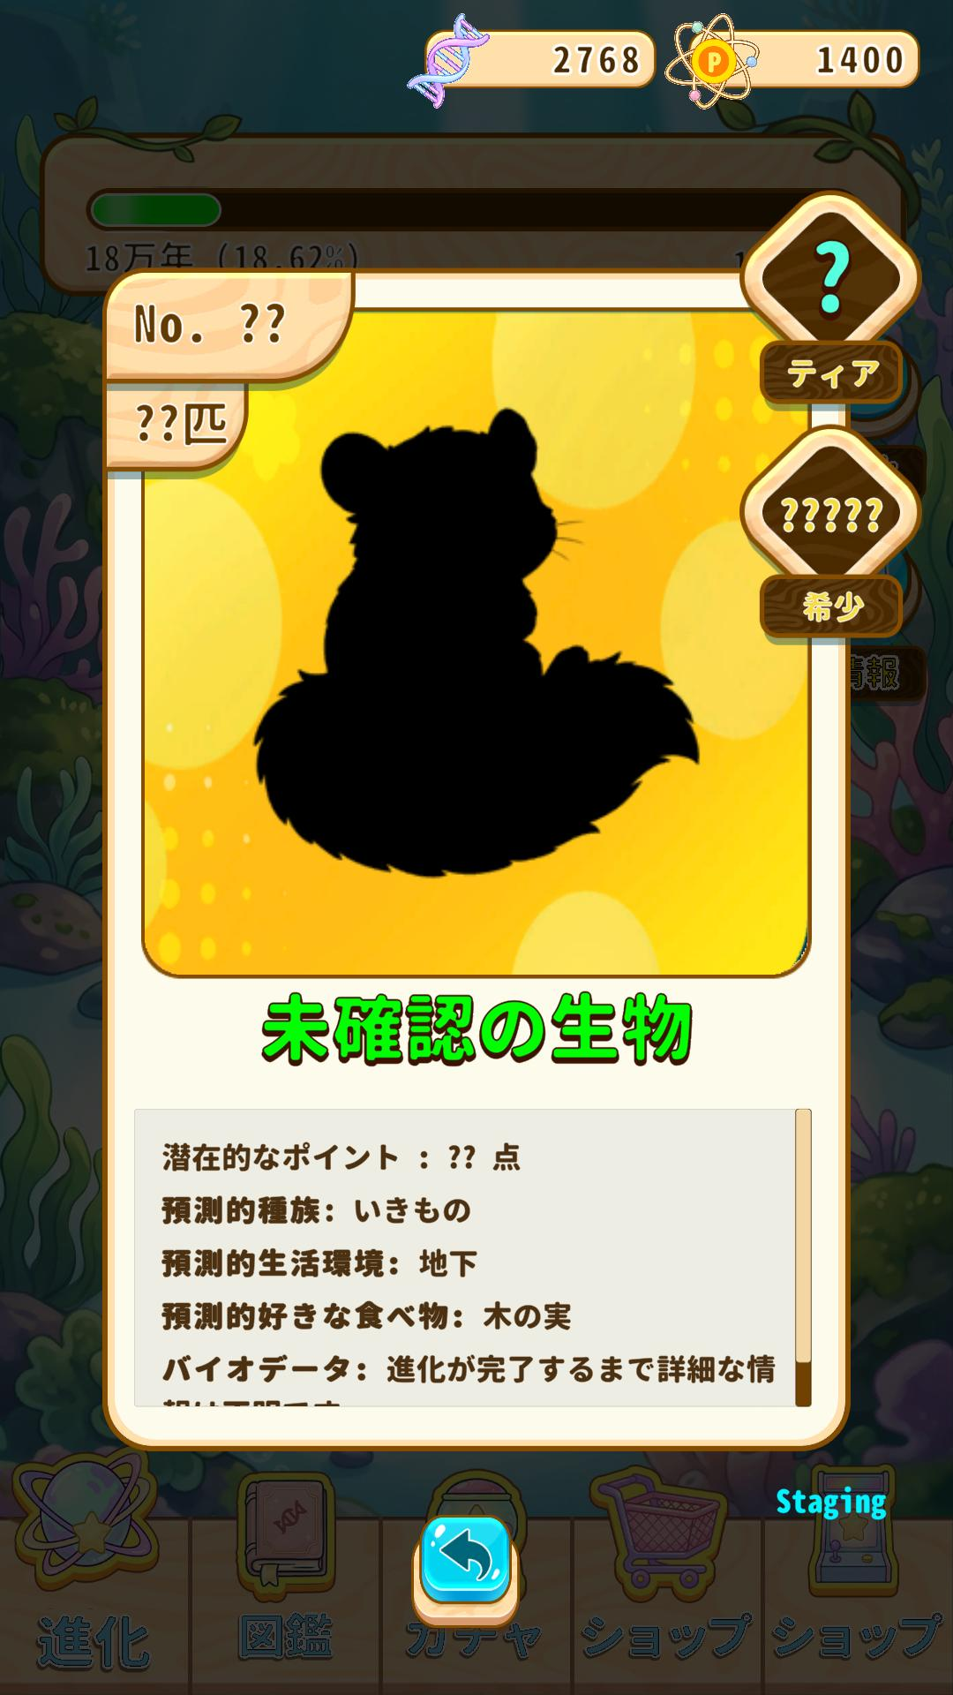
(1) Predictive information
Predictive information:
- Will show before the user unlock the creature, final information will show after the user unlock the creature.
- Predicted creature: is a creature that is random from the nearest creatures, only random 1 time after generating the creature.
- Predictive information is data of the Predicted creature.
- Uses in Incubator information, Codex and Final touch information
- The information is the .
Predictive information includes:
- Likely Category (random from the predicted creatures)
- Likely living environment (random from the predicted creatures)
- Likely Favorite food (random from the predicted creatures)

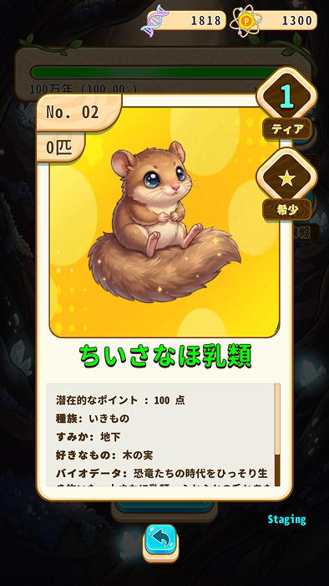
(2) Final information
Final information:
- Will show after the player acquires the creature.
- Used for result of Final touch and Codex
Final information includes:
- ID
- Number of creature of same type possessed
- Category
- Tier
- Rarity
- Name
- Potential point
- Living environment
- Favorite food
- Description

[Header("Basic Information")]
[SerializeField] private TextMeshProUGUI _nameText;
[SerializeField] private TextMeshProUGUI _idText;
[SerializeField] private TextMeshProUGUI _countText;

[Header("Predictive Information")]
[SerializeField] private TextMeshProUGUI _potentialPointText;
[SerializeField] private TextMeshProUGUI _categoryText;
[SerializeField] private TextMeshProUGUI _environmentText;
[SerializeField] private TextMeshProUGUI _favoriteText;
[SerializeField] private TextMeshProUGUI _bioDataText;

[Header("Final Information")]
[SerializeField] private TextMeshProUGUI _tierText;
[SerializeField] private TextMeshProUGUI _rarityText;
[SerializeField] private TextMeshProUGUI _descriptionText;


Content

(1) Rarity and tier
Rarity value: | Tier value:
  Name | Value
  N | 1
  R | 1.2
  SR | 1.4
  SSR | 1.6
  UR | 1.8
  Tier | Value
  Tier 1 | 100
  Tier 2 | 150
  Tier 3 | 200
  Tier 4 | 250
  Tier 5 | 300
There will be 60 creatures in this project.
Idle Birth Statitics

(2) Creature Statistic & Reward Formula
- Base Potential Point: Calculated as Tier value × Rarity value.
- Final Reward Calculation: The reward is derived from the formula: (Sum of Ingredients A+B+C+D) × Multiply Value.
- Environment Mapping: Creature backgrounds are determined by their specific habitat (e.g., Underground, Underwater, Ground, Sky, Galaxy Space).
- Environment Types:
  - Water Surface
  - Underground
  - Ground
  - Universe
  - Underwater
  - Civilization
  - Sky

(3) Important Design Notes
- Trypophobia Mitigation: To prevent discomfort when evolution creates clusters (multiple individuals), assets must be designed with reduced density and "cluster" effects.
- Visual Style: Character designs should align with the 'yuru-chara' (Japanese mascot) style, using a pastel warm color palette, smaller eyes, and restrained mouths.
- Information Hierarchy: Predictive information shown in the incubator represents probability ranges based on ingredient-matched potential points; Final information (post-unlock) should reflect the specific entity's immutable stats.

Characters design
The characters in current designs are placeholders.
The characters in this project should lean toward:
• Sumikko Gurashi (すみっコぐらし)
• Chiikawa (ちいかわ)
• Nameko Saibai Kit (なめこ栽培キット)
…the direction of "Japanese miscellaneous-goods style yuru-chara (mascot-style characters)".
[Features]
• Smaller eyes
• Restrained mouths
• Reduced sliminess
• Eased sense of density
• Pastel warm color palette
Also, for cases where growth ➡ multiple individuals occur, please reduce the "sense of cluster" so
as not to trigger trypophobia (fear of clusters)
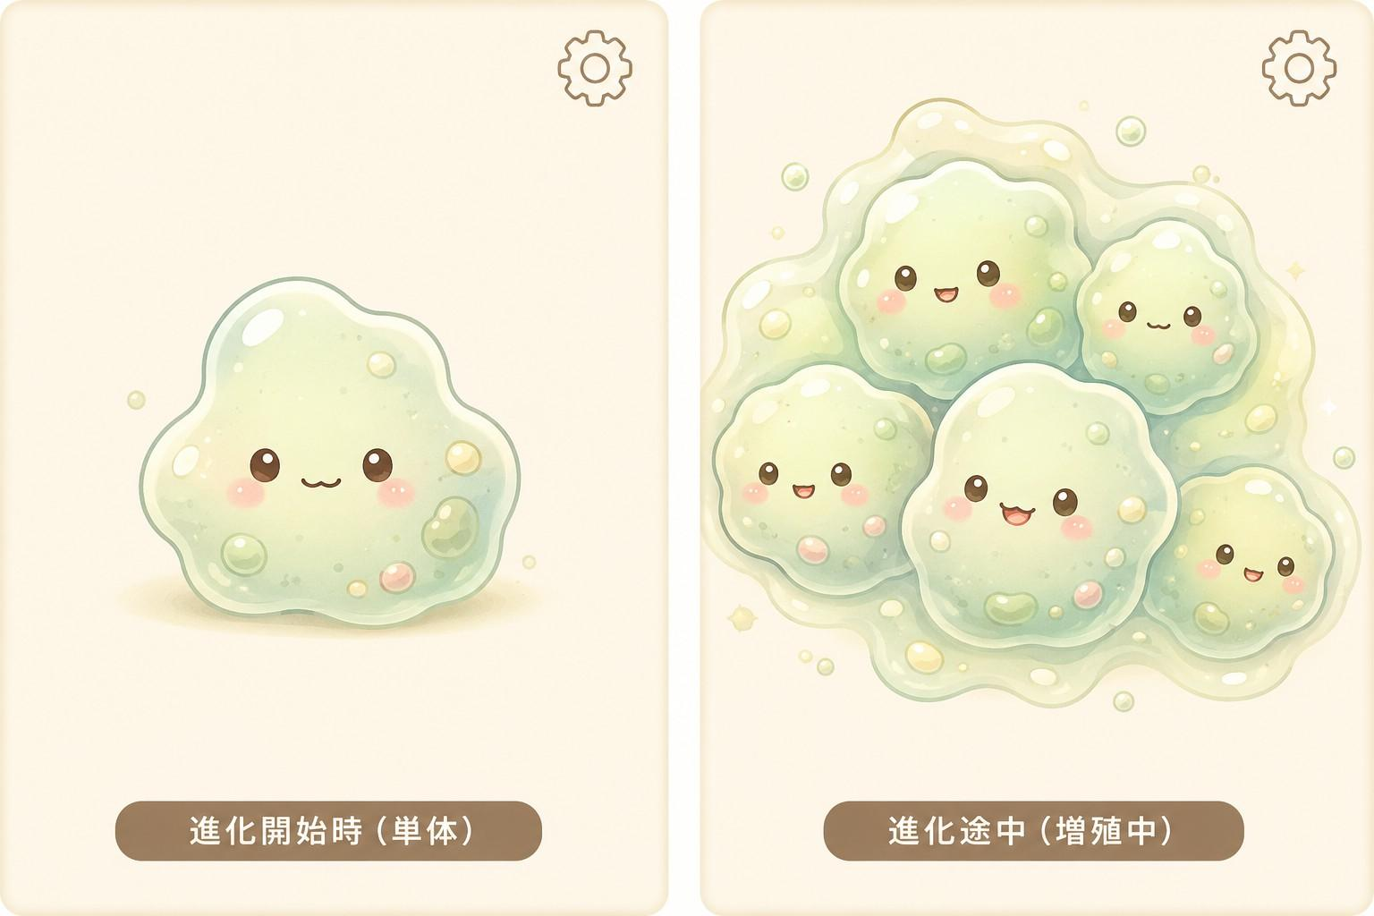
Here is the reference:

Currency

Two types of currency:
- DNA Strand:
Used in:
- Material synthesis for mixing Ingredients
- Play Gacha.
Acquired from:
- Completed Evolution Cycle
- Players receive DNA from ads when they don't have enough DNA to perform the chosen action.
- Potential Point
Used in:
- Exchange Rakuten Points.
Acquired from:
- Completed Evolution Cycle
- Gacha Rewards

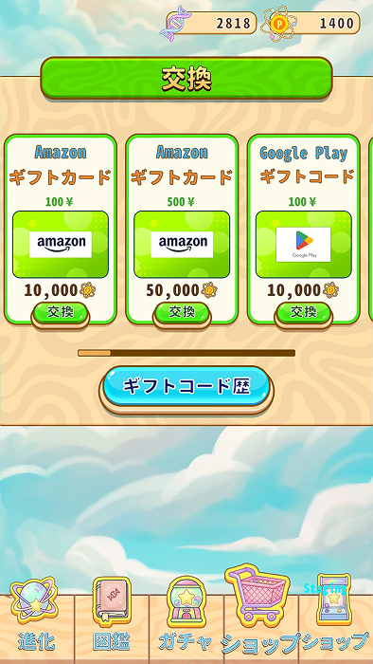
Shop
The Shop functions as:
Rakuten Exchange UI:
- Potential Points can be exchanged for Rakuten Points.
- The Gift Code History shows codes the player has already exchanged.
Multi-Provider Exchange: While the UI currently functions as a Rakuten exchange, it is being expanded to include other providers, specifically NTTCS.
Provider Expansion (OW): The system is scheduled to implement OW, which will necessitate updates and changes to the current User Interface to support the new integration.

Target Shop Platforms:
- Amazon
- Google Play
- Apple
- WAON POINT
- Nanaco
- au PAY
- PayPay
- Ponta
- D
- V

Ad monetization
Using AppLovin for ad monetization:
- Banner Ads: Enabled by default.
- MREC Ads: Displayed in all confirmation popups.
- Rewarded Ads: Used for speed-up mechanics, final touch, and gacha reroll.

Adjust analysis
Current Tracking Capabilities
- ADID Retrieval: On startup, AdjustManager.cs requests the user&apos;s ADID (Adjust.GetAdid) and saves it to the local save data GameStateData.AdjustAdId.
- Ad Revenue Tracking: Impression-level ad revenue tracking for AppLovin MAX ads is integrated in ApplovinMaxManager.cs.

(1) FAQ, tutorial, inbox, settings
Follow the standards of the previous project.

(2) Push notifications

Interval | Push Title | Push Body
6 Hours | Your creatures are missing you! | Your little creatures are waiting for you to help them evolve. Come say hello!
12 Hours | Time for a quick check? | The Growth Vat is ready for new ingredients. See what kind of life you can create today!
24 Hours | Potential Points waiting! | Your Lab has been quiet, but your potential points are still piling up. Come claim your rewards!
48 Hours | We miss you, Creator! | The Laboratory feels empty without you. Your creatures are waiting for your touch to guide their evolution.

